***Elevated TA conditions influence juvenile oyster growth when combined with a lower salinity***

1,2Saley, Alisha M., 2Kimball, Zoe & 1,2Brian Gaylord

1 Bodega Marine Laboratory, University of California Davis

2 Dept. of Ecology and Evolution, University of California at Davis

***Abstract—***

Response trajectory—do effects change over time, bigger/small and in what direction

Reasonable expectations; which one plays out

***Introduction—*** Coastal estuaries exhibit variability in the seawater carbonate system, with implications for calcifying inhabitants. For example, biogeochemical processing and river inflows can create deviations in total alkalinity (TA) from open-ocean values (Fassenberger et al. 2016, Montagna et al. 2018, Hunt). Likewise, salinities (S) can be modulated (ref.). Estuarine conditions are also temporally complex, with TA and salinity changing abruptly, often in conjunction with storms or seasonal shifts, and then persisting for days to months (Ricart et al. 2021, others). Such dynamics require that sessile calcifiers conform to new conditions and then endure them for sometimes extended durations. Given the multi-faceted extent to which seawater conditions dictate physiological and ecological performance of marine calcifiers (Hofmann and Todgham 2010, Gaylord et al. 2015), investigating responses to variation in TA and salinity deserves detailed attention.

Effects of variation in total alkalinity and salinity at scales local to individual estuaries also intersect with global perturbations. Approximately a third of human-produced carbon dioxide emitted to the atmosphere absorbs into the oceans (Sabine et al. 2004). Changes to multiple components of the carbonate system of seawater ensue (causing ‘ocean acidification;’ Caldeira and Wickett 2003). Thus, both small- and large-scale processes governing variation in TA and S operate within estuaries and can impact the ability of shell-forming taxa to precipitate their calcium carbonate structures.

Substantial effort has documented how calcifier growth can be disrupted by an altered carbonate system. A subset of this work has emphasized effects of temporal characteristics of exposure (e.g., static versus fluctuating conditions, often of pH or CO2), both within and across life stages. SUGGEST POTENTIAL RESPONSE PATTERNS These efforts have shown that the time course of exposure indeed influences growth and other aspects of performance (cite). However, gaps remain in our understanding of whether responses to sudden changes in the carbonate system manifest quickly or build up more slowly, and whether responses continue to hold or abate as perturbed conditions persist. Such “step change” exposures are not uncommon in nature, and their durations can differ across systems and localities. Therefore, information regarding the trajectory of calcifier responses across time is valuable. These points become especially relevant to dissecting potential physiological trade-offs in energy allocation – for example among growth (shell or tissue), reproduction, movement, and maintenance – each of which has its own time course and metabolic pathway.

Explorations of how growth rate responds to altered TA and S are especially suited to extending prior work. For example, extensive research has documented disrupted growth in bivalves under ocean acidification (for review see Gazeau et al. 2013), but few if any of these studies have deliberately examined effects of modifying TA. Similar limitations in experimental manipulation of TA apply to X, Y, Z [could insert other taxonomic groups where there are reviews]. Strong drops in salinity are likewise known to affect growth (cite). However, potential correlations between decreased S and TA may have unintentionally blurred the relative importance of these two factors in many such studies. Therefore, explicit tests of effects of TA and S on calcification abilities of coastal and estuarine taxa are needed.

Oysters have significant economic and ecological value to coastal populations of humans and wild organisms alike. Because many oyster species create structure-forming reefs, they often provide habitat for other estuarine taxa (cite). They also help protect against shoreline erosion from waves (Reidenbach). Commercially, when reared and harvested for human consumption, they contribute to a globally-expanding shellfish diet (cite). In the latter context, relative and absolute amounts of shell and tissue mass become relevant.

Here we explore how total alkalinity and salinity affect growth of juvenile Eastern oysters (*Crassostrea virginica*), with special attention to the temporal trajectory of response to step changes in seawater TA and S. In particular, we examine how growth in shell area differs between an earlier time window, starting immediately after treatment conditions are implemented, and a later time window two weeks later. In these efforts we also account for the size of oysters at the beginning of each time window. At the end of the experiment, we additionally compare a metric of oyster shell thickness (shell mass per area) and condition index (tissue mass per shell mass) across different TA and salinity exposures. Examinations such as these lend insights into ways in which calcifying estuarine species may respond across time to abrupt and then persisting shifts in seawater carbonate chemistry.

***Methods—***

**Study species—** The Eastern oyster, *Crassostrea virginica*, is native to estuaries of eastern North America, from the Gulf of St. Lawrence to the Gulf of Mexico. (cite) Due in part to its wide salinity and thermal tolerance, this species is also grown commercially elsewhere, including X (cite), For our experiments, we sourced juvenile oysters from a local aquaculture farm in Tomales Bay, California, USA (Hog Island Oyster Company; coordinates). On 22 July 2022, we transported oysters in cool seawater from Tomales Bay to Bodega Marine Laboratory (BML; Bodega Bay, California, 60 min transit time), and placed them immediately into flow-through, continuously bubbled seawater drawn from the adjacent ocean. We fed the oysters with slow-release mixed algal diet (X% of their wet mass; [**provide supplier**]) once every two days, throughout a 30-d lab acclimation period. At the end of the acclimation period, we glued the oysters (left valve) to plastic plates using X marine epoxy (n = 49 per plate, n = 12 plates) following X et al (cite year). We then returned the plates with attached oysters to the acclimation tanks, and three days hence began a 36-d growth experiment (Fig. 1).

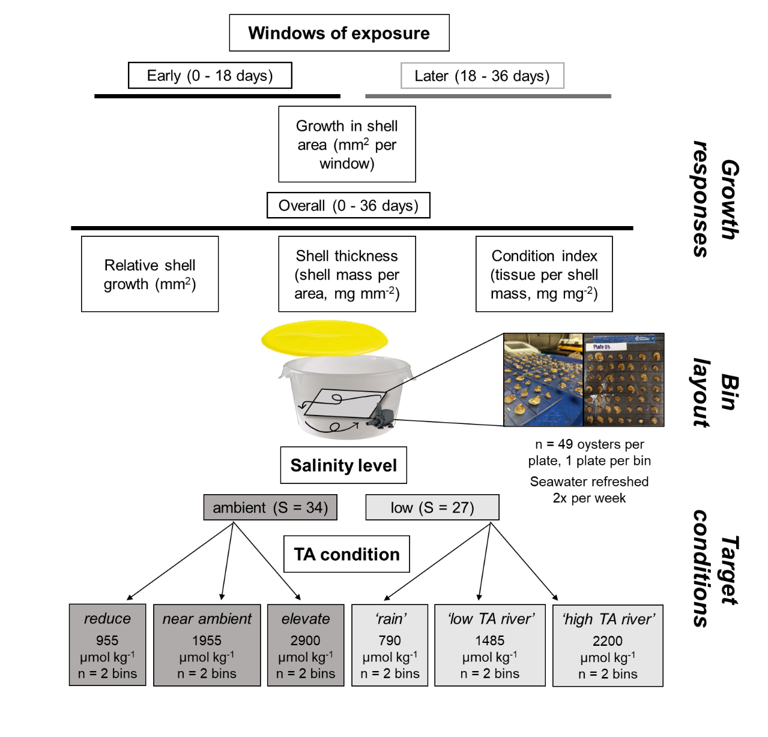

Fig. 1. Schematic of A) experimental culture conditions and B) measured growth responses as a function of exposure window. We conducted growth experiments of C virginica oysters across 6 TA conditions within 2 salinities. Oysters on plates were positioned horizontally, facing toward continuous seawater circulation in the bins. We measured *growth in shell area* in an early (0-18 days) and later (18-36 days) window. We measured *relative shell growth* (per 36 days), shell thickness (mg mm-2), and the condition index (mg mg-2) only at the end of the experiment.

**A**

**B**

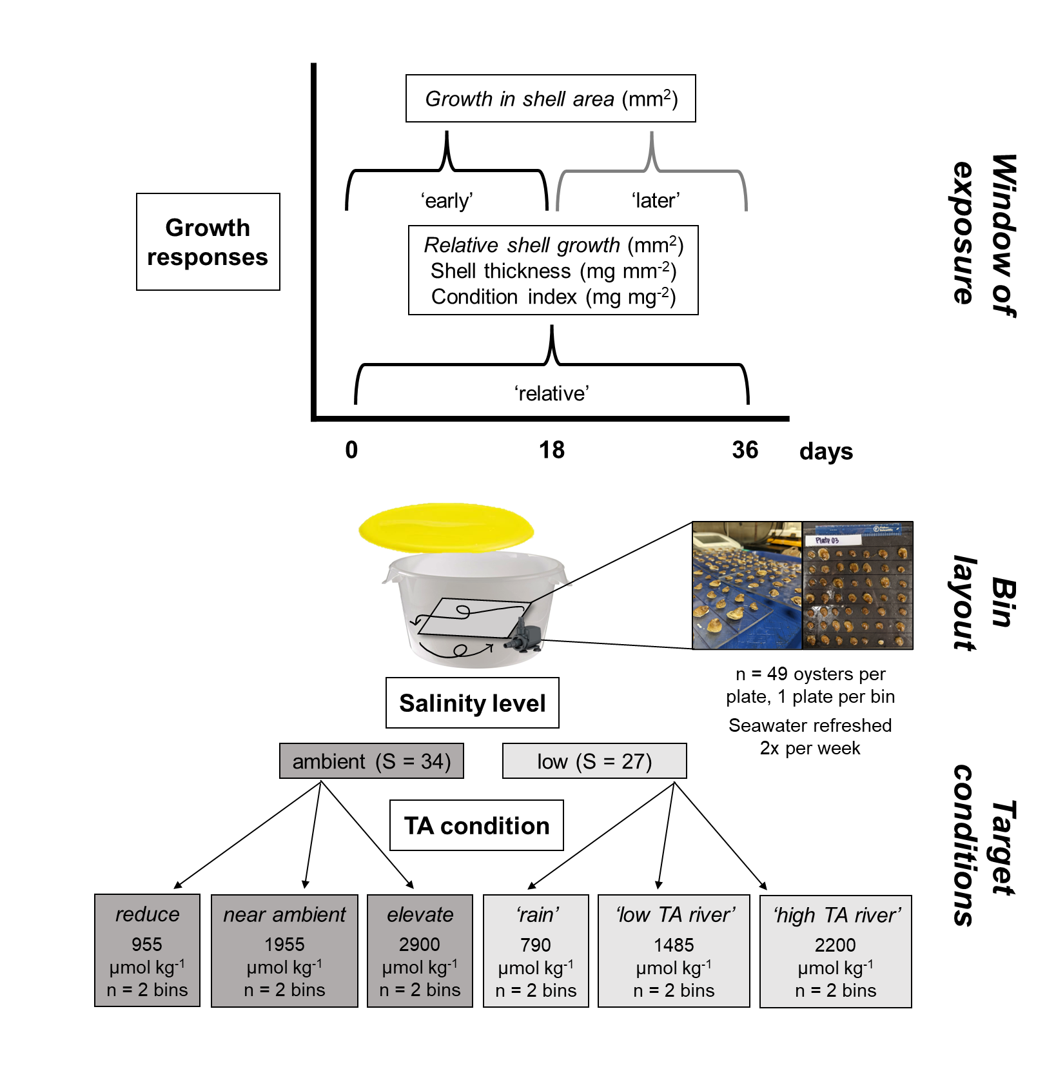

Fig. 1. Schematic of A) experimental culture conditions and B) measured growth responses as a function of exposure window. We measured growth in juvenile C. virginica oyster shell area in an early (0-18 days) and later (18-36 days) window. We measured relative shell growth (per 36 days), shell thickness (mg mm-2), and the condition index (mg mg-2) only at the end of the experiment.

**A**

**B**

**Design of experiment—** Our primary aim was to determine effects of total alkalinity on growth in oyster shell area. We established six treatment levels of TA, spanning conditions characteristic of estuaries with substantial rainwater input (low TA), through more typical alkalinity conditions (intermediate TA), to conditions observed in estuaries supplied by watersheds of high-carbonate geology (high TA). Because streams and rivers that deliver low- or high-TA fresh water can simultaneously decrease estuarine salinity, we also established two treatment levels of salinity, an ambient level (S=34) and a reduced salinity level (S=27). The resultant experimental design linked treatments of both lower and higher TA with both low and ambient salinity. Although the treatment conditions were not fully orthogonal, this design enabled exploration of independent effects of TA and S across a spectrum of environmental conditions relevant to *C. virginica*. Each TA and S treatment combination (6 total) was replicated across two static culture chambers, each containing one plate with 49 attached oysters. The overall configuration thus summed to 49 oysters x 2 cultures x 6 treatments = 588 oyster individuals across the experiment.

We were additionally interested in whether oysters might respond in a different way immediately following exposure to a novel set of TA and S conditions, compared to a response later on after the exposure had continued for multiple days. We therefore sampled growth in shell area at several time points throughout the 36-d experiment, focusing especially on growth across two time windows, one earlier (days 0-18) and one later (days 19-36).

**Oyster growth—**We tracked changes in shell surface area throughout the experiment, taking photos of shell area on day 0, day 18, and day 36. We analyzed the photos using ImageJ software (v.X) to determine projected surface area of each oyster’s top valve, ensuring a scale bar was visible in each image. We quantified the growth in shell area (difference in shell area between start and end dates) within earlier and later windows, and the overall shell growth across the full 36 days of the experiment. We additionally measured condition index at day 36, which we quantified as dry tissue mass per dry shell mass, after separating the tissue from the shells and drying each at 60°C for 48 hr. We then divided shell mass by shell area to develop a rough metric of shell thickness.

**Culture conditions—** Each static culture during the experiment included an aquarium pump to ensure adequate water motion. The continuous stirring allowed gas exchange at the water’s surface to keep oxygen levels at >80% saturation . The only exceptions were two cultures that dropped to X% on one occasion each, due to pump failure. The resulting episodes of decreased oxygen lasted less than X hr. Oysters were fed daily [with X], and were held in the dark to minimize the influence of shadows on activity (cite). Complete water changes were done every three days, and the sides of the culture chambers, and pumps, cords, and tubing were cleaned of any fouling organisms and debris. The experimental cultures had lids but were not tightly sealed due to a gap created by the pump power cord, which resulted in minor chemical drift between water changes (Fig. 2). Despite this drift, chemical conditions across treatments remained distinct and differed statistically. Any mortality of oysters (always <X%) was recorded at the same time as water changes, and shells of deceased oysters were promptly removed from the cultures and discarded.

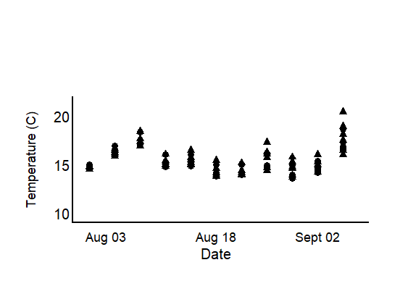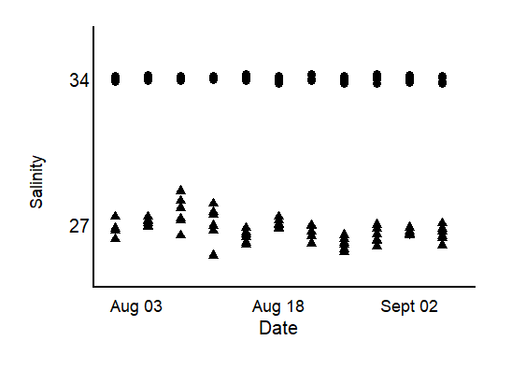

Fig. 2. Results of treatment monitoring of seawater throughout the experiment exhibit marginal variability in A) total alkalinity (unit), B) salinity, and C) temperature (unit) conditions throughout the experiment, though, treatments remained distinct. Measurements for temperature and salinity were taken prior to, and after, water changes using a multiparameter sonde. We collected seawater at the same time to later analyze for total alkalinity. A) Total alkalinity targets were duplicated across 6 ranges that spanned far below to well above ambient seawater conditions (~2250umol kg).. Dashed lines indicate the average TA condition in each bin (legend).B) Very little variability in ambient salinity conditions with low salinity conditions ranging from X to X, with an average of X +_ SE. C, denoted by marker shape (triangle S=27, circle S = 34). In all bins seawater temperature fluctuated between X and X (average X + SE C).

**C**

**B**

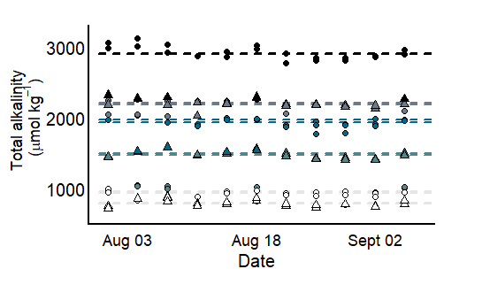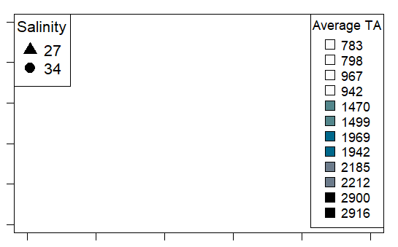

**A**

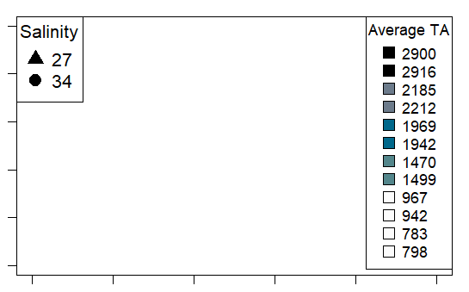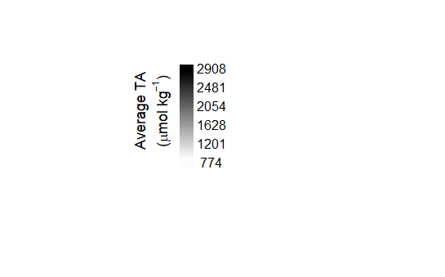

Before and after each water change during the experiment, we measured seawater temperature, salinity, pH, and dissolved oxygen concentration with a handheld multi-parameter sensor (YSI X). In X percent of pH measurements, we collected and analyzed discrete bottle samples for spectrophotometric determination of pH (calibrated on the same day with m-cresol dye standards, Easley and Byrne 2015), and used the latter data to translate pH data to the total scale. We also collected and immediately froze 250 ml seawater samples before and after each water change for later alkalinity determination. We quantified seawater TA in triplicate using a Metrohm 855 Titrosampler, correcting titration acid concentration daily with certified reference materials from the laboratory of Dr. Andrew Dickson (Scripps Institute of Oceanography). Finally, we used measurements of seawater TA (µmol kg-1) and pH (total scale) at specified salinities and temperatures to estimate the remaining seawater carbonate system parameters with the *seacarb* package in the software R (version 3.3.1). In our *seacarb* estimates, we used equilibrium constants from Lueker et al. 2000 (K1 and K2), Perez and Fraga 1987 (Kf), and Dickson 1990 (Ks). For simplicity, we refer to the seawater carbonate system in terms of TA, though additional carbonate system parameters vary in conjunction with shifts in alkalinity (Table S1), some of which may influence oyster growth separately from salinity and TA (cite).

**Chemical manipulation of seawater—** Seawater chemical conditions at the beginning of the experiment and at each water change were established as follows. We first depleted seawater TA to negligible concentrations in large sumps (n = 4 sumps/water change) by adding hydrochloric acid (HCl) to drive the carbonate system reactions towards CO2, which then off-gassed over two days in conjunction with strong bubbling with air. We then mixed the TA-depleted seawater with distilled fresh water and premade solutions of NaHCO3 (sodium bicarbonate) and Na2CO3 (sodium carbonate) with HCl to adjust the carbonate system back to desired salinity and TA levels (Waldbusser et al. 2015, Ninokawa et al. in review).

**Statistical analysis—** All statistical tests were performed in R Studio (ver. 2022.07.02). We used a mixed effects model (*nlme*, *lme4*) to explore how TA affects growth in shell area over the course of an exposure, across two salinity levels, and as a function of initial oyster size. We explored growth responses during two temporal periods: an earlier response window (days 0-18), and a later response window (days 19-36). The initial size corresponded to the projected surface area at the beginning of the time window under consideration. Total alkalinity and initial oyster size were treated as continuous, fixed effects, whereas salinity (ambient versus low) and response window (earlier versus later) were included as categorical effects. We incorporated oyster individual and culture chamber as random intercepts to account for the lack of independence associated with repeated sampling of the same oysters and the lack of independence of oysters within a given culture. In the resulting analysis output, the effect of the earlier time window is considered the ‘default’, and as such, reported model estimates of the intercept and fixed effects (slopes) refer effects within the earlier window. T effect of the second time window appears via the interaction terms between TA or salinity and response window. We used similar models to test the influence of TA, salinity, and initial oyster size on overall growth over the full 36 days of the experiment. The influence of these latter three predictors on shell thickness (shell mass per area, mg mm-2) and condition index (tissue mass per shell mass, mg mg-2) were also tested, including culture chamber as a random intercept. We added a weighted variance term to models that failed the Breusch-Pagan test (*lmtest*) for residual heteroscedasticity, which specifies that the weight of each data point is equal to the proportional variance across bins. Assumptions of normality were visually assessed with qqplots and histograms of model residuals. We employed backwards step-wise model selection to test the effect size of parameters found significant in the model, running ANOVA comparisons between a full model and one with a given parameter omitted. The computed L-ratios, shown in Tables 1-4, indicate a proportional effect size relative to other predictors in the model, at a given p-value.

***Results—***

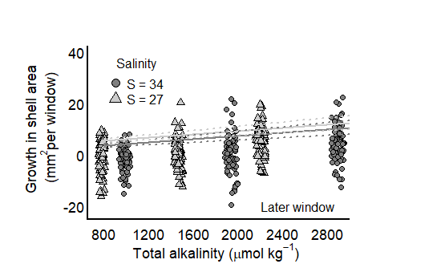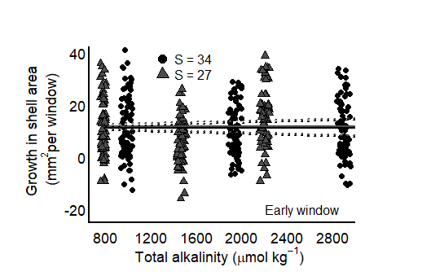

Fig. 3 Growth in shell area does not exhibit separate relationship with salinity (grayscale) in neither the A) early (0-18 days) nor B) later (19-36 days) window in juvenile *C. virginica* oysters. Model predicted intercepts and slopes (line) and SE borders (dashed line) were taken from a mixed-effects model, and therefore incorporate the effect of other model predictors (Table X).

**B**

**A**

**Growth in shell area—** Growth in oyster shell area was higher during the earlier (0-18 d) response window than the later (19-36 d) response window (compare response scales between panels in Fig. 3). This difference was appreciable, with growth during the second time window dropping to **X**% of that observed during the first window of the same length. Total alkalinity did not influence growth in shell area during the earlier response window, but TA had a positive effect during the later response window (Fig. 3B; Table 1). The pattern during the later window may indicate that TA is more important in situations where rates of calcification of oysters are reduced by other factors. Salinity did not affect growth in shell area in either time window (Fig. 3, Table 1). In the earlier response window, there was a positive relationship between initial size and growth, while the relationship was reversed in the later window (Fig. 4, Table 1).

Fig. 4 Growth in shell area (unit) exhibits different relationships with size at the start of the period, between early (0-18 days) and later (18-36 days) exposure windows in juvenile *C. virginica* oysters. In the early window growth was higher in larger oysters (black points), where larger oysters exhibited lower growth in the later window (grey points). Intercept and slope model predictions (line) and SE borders (dashed lines) were taken from a mixed-effects model in Table X.

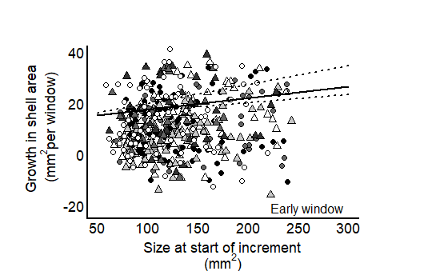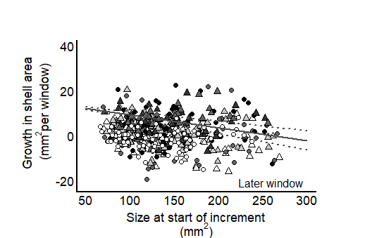

**B**

**A**

Fig. 5. Neither changes in total alkalinity (unit) nor salinity level (color) influence the relative growth in shell area (unit) of juvenile *C. virginica* oysters after 5 weeks of exposure to altered conditions. Intercept and slope model predictions (line) and SE borders (dashed lines) were taken from a mixed-effects model in Table X.

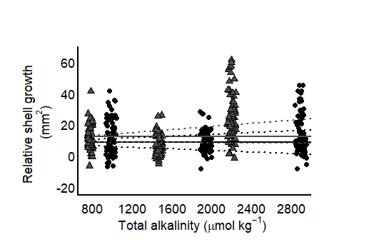

**Overall shell growth—** When overall growth spanning both time windows (i.e., over the full duration of the 36 d experiment) was computed, effects of TA were no longer apparent (Fig. 5, Table 2). Likewise, salinity did not influence growth in shell area after 36 days. However, the overall growth in shell area did increase with the initial size of oysters, similar to the earlier of the two time windows (but not the later window). Maybe add some comments here about the variability in the data relative to the time window?

**Shell thickness & condition index—** Neither shell thickness nor condition index, both assayed at the end of the experiment at day 36, showed an influence of total alkalinity or salinity (Fig. 6). However, oysters with larger initial shell areas tended to have a higher condition index. Shell thickness exhibited no trends as a function of initial oyster size. Average tissue mass did greatly exceed that of un-fed oysters held in lab seawater (ave. unfed = X vs fed = X) indicating an ability of all oysters to assimilate and store food as tissue mass, regardless of seawater treatment.

Fig. 6. Neither changes in total alkalinity (µmol kg-1) nor salinity level (color) influence A) shell thickness (mg mm2) or B) the condition index (mg mg2) of juvenile in *C. virginica* oysters. A lack of an effect of TA may suggest that trade-offs in other growth metrics, in order to maintain relative shell growth, did not occur.

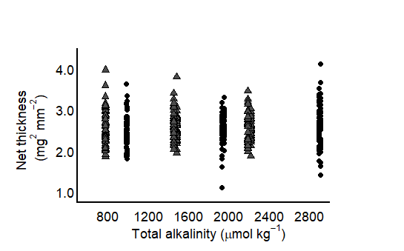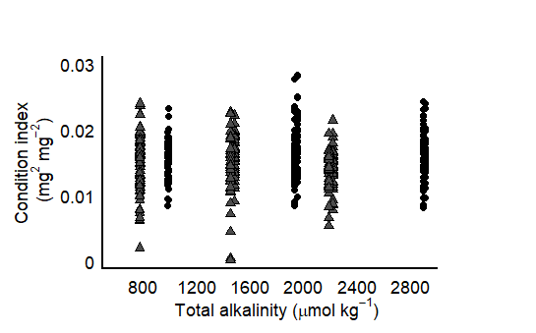

**B**

**A**

***Discussion—***

**The effect of altered TA on growth in shell area varied between exposure windows but did not manifest in overall shell growth or tissue growth, in either salinity treatment, in juvenile Easter oysters.** In the earlier window, growth in shell area was neither influenced by altered TA nor salinity, but increased with the size of the individuals (Fig X), suggesting that X. In the later window we detected higher growth with higher TA, while shell growth in low TA conditions declined (Fig. X). The scale of shell growth was lower in the later period for all oysters, however, which masked the (later window) effect of TA in overall shell growth (0 – 36 days). Oysters that were exposed to the lowest TA conditions in both salinities likely experienced an increased tendency for external shell dissolution from under-saturated seawater conditions (in respect to calcite CaCO3), though, we did not detect consequences on abiotically-driven shell loss in area growth, nor thickness. These trends, again, may indicate the import of biological activity, both in scale and through time, in mediating the effect of seawater conditions.

**Although the effect of TA on shell growth was insignificant in the earlier window, this could indicate the ability of oysters to rapidly acclimate to, and grow in, TA-disruptions to the carbonate system, even under corrosive seawater conditions.** Unlike studies that have demonstrated disruptions to shell building under ocean acidification conditions, including multiple focusing on (age) C. virginica, we did not see an initial nor overall effect of TA. This is despite the fact that our two lowest TA targets fell below the saturation state for calcium carbonate, indicating corrosive seawater conditions for shell material. One possibility is that individuals were able to biologically compensate for external shell loss in a well-fed environment (cite). Moreover, we detected higher shell growth from oysters that were initially larger in size, which could indicate an increased surface area available to calcify onto or an ability of larger oysters (with maintained tissue reserves) to maximize shell growth. Although changes in TA vs pCO2 could separately lead to corrosive seawater conditions, they likely have different mechanistic import for growth pathways. For example, ocean acidification conditions describe the increased uptake of atmospheric CO2 in seawater without a coinciding increase in TA (buffer), which can lead to a reduction in pH. A reduction in seawater TA could also result in reduced pH, though, this is due directly reducing the buffering capacity of seawater in unchanged pCO2. ***mechanistically this is why it is important to differentiate between increased co2 and decreased ta. examples with other species.*** Given that other coastal calcifiers have shown disruptions to shell growth under altered pCO2 conditions, it would be interesting to see whether the sensitivity matches under changes in TA.

**Declines in the scale of shell growth coincided with an effect of TA on shell growth, which may suggest that the effect of TA was biologically mediated.** Others, including work from our group, have demonstrated an effect of direct biological compensation by the calcifier in off-setting seawater-driven dissolution in other calcifying species (cite), along with the role of organic, protective layers that can reduce dissolution rates through minimizing contact between seawater and shell (cite). Specifically, we have previously detected an effect of biological activity in mediating short-term calcification responses in another coastal calcifier, the California mussel (*Mytilus californianus*). In the mussel species, however, we found that sharp declines in shell building corresponded to a particular salinity, below which, resulted in reduced oxygen consumption, a response sometimes measured as a proxy for organism activity. Here we did not measure oxygen consumption activity between the two periods and so we can only speculate that reduced, later window shell growth could have stemmed from declines in overall activity. Future work may benefit from measuring changes in activity level through time in conjunction with shell building performance in order to normalize for activity.

**Another possibility is that an effect of low TA arose in the later window because some form of external shell protection that was present in the earlier window to prevent seawater contact with the shell, was no longer present in the later window.** For example, other calcifying species have demonstrated the effect of an organic layer, i.e. the periostracum, in protecting underlying shell material from dissolution (ptero, us), though oysters are generally thought to lose this layer through X process (cite). Though we did not attempt to identify potential sources of surface cover protection in oysters, we noted a discoloration in the shells through time as a function of TA condition (Fig X). Bleaching of the exterior of the shell has indicated the loss of a surface epiphyte (cite) or X (cite) in other bivalve species, which once removed, may allow for corrosive seawater to interact, and dissolve exterior shell (cite).

**We did not detect differences in shell thickness, or the condition index of oysters based on TA or salinity exposure, indicating that energy allocation to the X (name for all three responses?) was uninhibited after 36 days**. We did not sacrifice individuals on day 18 to measure thickness or condition index, however, and so we cannot indicate whether there were initial trade-offs during higher growth in shell area activity. What could have happened, is that oyster shell growth was maximized in the earlier window, meanwhile depleting tissue reserves in order to keep up with increasing energetic cost under corrosive seawater conditions. Then, we could have observed a decline in shell growth activity corresponding to a physiological shift to rebuilding/regenerating shell thickness and tissue reserves. This has been detected in X species (cite), though, others have indicated that well-fed individuals are not often energetically limited (cite), in which case, we could have been measuring natural shifts in prioritizing metabolic pathways. Future studies that are able to decouple naturally shifting metabolic pathways from disruptions of altered seawater conditions in *C. virginica* and other calcifying species would be beneficial.

**Though we did not detect negative consequences to shell or tissue growth from salinity reduced to 27, more drastic declines in salinity that are forecasted with extreme precipitation events may have an interaction with the effect of TA.** Especially along the Atlantic and Gulf coast of the United States, where *C. virginica* provides vital coastal habitat and economic services, hurricanes are becoming more frequent and severe (cite). In some cases, storms lower salinity to X% of ambient over the course of X time period (cite) and have caused these issues to coastal communities (cite). Increasing extreme precipitation events along the US West have resulted in mass mortality events of other oyster populations, though *C. virginica* is thought to be one of the more tolerant oyster species to low salinity environments. The extent to which *C. virginica* oysters may be able to hand shifts in TA in more drastic reductions in salinity, like those corresponding to extreme storms, could provide insight as to whether lower salinities would have a similar negligible interaction with variable TA on shell growth.

**Final paragraph: Additional work investigating the temporal strength of responses in a variety of coastal calcifiers should be prioritized. Blah blah blah**

***Tables—***

Table 1. Results of mixed effects, linear model testing the effects of TA and initial size on *growth in shell area* (mm2) between two salinities, as a function of exposure window (earlier or later) in juvenile *Crassostrea virginica* oysters exposed to altered seawater conditions for 5 weeks. The difference in surface area was calculated relative to the size of the oyster at the beginning of the experimental window. L-Ratios and p-values were recorded during backward stepwise model selection and refer to the ANOVA test output between the full model and a model with the specified predictor omitted. L. Ratios were not computed for parameters found to be insignificant. Bolded values denote a significant effect, determined by alpha < 0.05. The final model: Incremental growth rate ~ size + categorical(salinity, 2 levels) + continuous(TA) + categorical(time period, 2 levels) + interaction (TA: time period) + interaction (S + time period) + RI(culture chamber), accounted for ~ 30% of the variation.

|  |  |  |  |  |  |  |
| --- | --- | --- | --- | --- | --- | --- |
| **Fixed Effects**  marg. r2 = 0.30  cond. r2 = 0.30 | **Estimate** | **Std. Error** | **t-value** | **df** | **L. Ratio** | **p-value** |
| Intercept | 1.7609 | 0.2019 | 8.7220 | 446 | -- | **< 0.0001** |
| Salinity | -0.0091 | 0.0576 | -0.1586 | 446 | -- | 0.8740 |
| Initial size | 0.0012 | 0.0004 | 2.7984 | 445 | 6.5126 | **0.0016** |
| TA (umol kg-1) | 1.3900e-05 | 4.0090e-05 | 0.3478 | 446 | -- | 0.7281 |
| Time window | -0.0653 | 0.0069 | -9.4658 | 445 | -- | **< 0.0001** |
| Interaction (TA: window) | 0.0002 | 0.0001 | 3.5412 | 445 | 12.5400 | **0.0004** |
| Interaction (Salinity: window) | 0.1855 | 0.0814 | 2.2796 | 445 | 5.1965 | **0.2294** |
| **Random Effects** | **Intercept** | **Residual** |  |  | **L. Ratio** | **p-value** |
| Individual | 2.1804e-05 | 0.5762 |  |  | 6.3379e-07 | 0.9994 |
| Culture chamber | Add | Add |  |  | Add | add |

Table 2. Results of mixed effects, linear model testing the effects of TA, salinity (categorical), and initial size on net shell growth rates (mm2 d-1) in juvenile *Crassostrea virginica* oysters. The difference in surface area was calculated as the difference between starting and ending shell size. L-Ratios and p-values were recorded during backward stepwise model selection and refer to the ANOVA test output between the full model and a model with the specified predictor omitted. Bolded values denote a significant effect, determined by alpha < 0.05. The final model: Net shell growth rate ~ size + categorical(salinity, 2 levels) + continuous(TA) + RI(culture chamber), accounted for ~ X% of the variation.

|  |  |  |  |  |  |  |
| --- | --- | --- | --- | --- | --- | --- |
| **Fixed Effects**  marg. r2 = 0.16  cond. r2 = 0.52 | **Estimate** | **Std. Error** | **t-value** | **df** | **L. Ratio** | **p-value** |
| Intercept (ambient S) | -0.0743 | 0.1611 | -0.4615 | 436 |  | 0.6447 |
| Low S | 0.0743 | 0.1060 | 0.7009 | 9 |  | 0.5011 |
| Initial size (mm2) | 0.0020 | 0.0002 | 8.9071 | 436 |  | **< 0.0001** |
| TA | 0.0001 | 0.0001 | 1.4194 | 9 |  | 0.1895 |
| **Random Effects** | **Intercept** | **Residual** |  |  | **L. Ratio** | **p-value** |
| Culture chamber | 0.1681 | 0.1956 |  |  | 95.48962 | < 0.0001 |

Table 3. Results of mixed effects, linear model testing the effects of TA, salinity (categorical), and initial size on shell thickness (mg mm2) in juvenile *Crassostrea virginica* oysters. L-Ratios and p-values were recorded during backward stepwise model selection and refer to the ANOVA test output between the full model and a model with the specified predictor omitted. Bolded values denote a significant effect, determined by alpha < 0.05. The final model: Net shell thickness ~ initial size + categorical(salinity, 2 levels) + continuous(TA) + RI(culture chamber), accounted for ~ X% of the variation.

|  |  |  |  |  |  |  |
| --- | --- | --- | --- | --- | --- | --- |
| **Fixed Effects**  marg. r2 = 0.01  cond. r2 = 0.01 | **Estimate** | **Std. Error** | **t-value** | **df** | **L. Ratio** | **p-value** |
| Intercept (ambient S) | 2.4040 | 0.0803 | 29.9037 | 436 | -- | **< 0.0001** |
| Low S | 0.0355 | 0.0394 | 0.9002 | 9 | -- | 0.3915 |
| Initial size (mm2) | 0.0006 | 0.0004 | 1.3511 | 436 | -- | 0.1774 |
| TA | 4.4500e-05 | 2.7460e-05 | 1.6220 | 9 | -- | 0.1392 |
| **Random Effects** | **Intercept** | **Residual** |  |  | **L. Ratio** | **p-value** |
| Culture chamber | 0.01 | 0.01 |  |  | 0.0130 | 0.9091 |

Table 4. Results of mixed effects, linear model testing the effects of TA, salinity (categorical), and initial size on condition index (mg mg-2) in juvenile *Crassostrea virginica* oysters. L-Ratios and p-values were recorded during backward stepwise model selection and refer to the ANOVA test output between the full model and a model with the specified predictor omitted. Bolded values denote a significant effect, determined by alpha < 0.05. The final model: Condition index ~ size + categorical(salinity, 2 levels) + continuous(TA) + RI(Culture chamber), accounted for ~ X% of the variation.

|  |  |  |  |  |  |  |
| --- | --- | --- | --- | --- | --- | --- |
| **Fixed Effects**  marg. r2 = 0.15  cond. r2 = 0.28 | **Estimate** | **Std. Error** | **t-value** | **df** | **L. Ratio** | **p-value** |
| Intercept (ambient S) | 0.0262 | 0.0042 | 6.1850 | 436 | -- | **< 0.0001** |
| Low S | -0.0035 | 0.0027 | -1.3166 | 9 | -- | 0.2205 |
| Initial size (mm2) | 0.0001 | 1.1252e-05 | 8.5433 | 436 | 69.7660 | **< 0.0001** |
| TA | 1.3980e-05 | 1.8430e-06 | 0.7583 | 9 | -- | 0.4677 |
| **Random Effects** | **Intercept** | **Residual** |  |  | **L. Ratio** | **p-value** |
| Culture chamber |  |  |  |  | 33.7828 | **< 0.0001** |